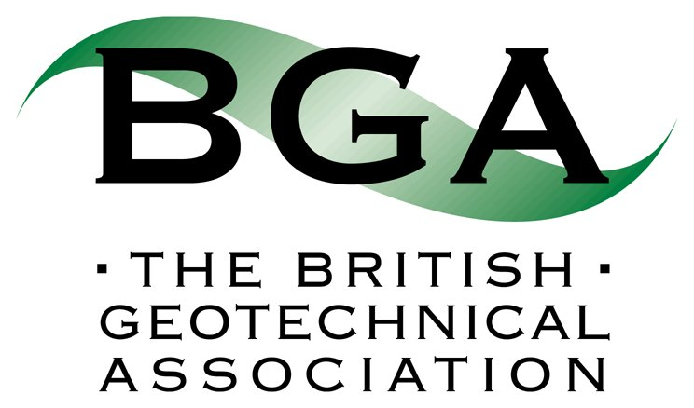 BGA Fund Award 2017 - Referee form
Deadline
The deadlines for applications are 31st May 2017 and 30th November 2017. This form should be submitted in support of an application by these deadlines.
Submission
Please email your signed referee form to the BGA Co-ordinator (bga@britishgeotech.org.uk).
Referee information (Please use block capitals)
Title |  | Surname
First name(s)
Organisation |  | Position
Address
Country |  | Postcode
E-mail |  | Telephone No.
Applicant details
Name of Applicant
Sponsor Statement

Please give reasons why you believe the applicant should be considered for a BGA Fund award including how you believe the proposed study will benefit his/her career.
Declaration
I hereby certify that all the information given by me on this form is correct to the best of my knowledge.
Signed |  | Date

The British Geotechnical Association undertakes that it will treat any personal information (that is data from which you can be identified, such as your name, address, e-mail address etc) that you provide to us, or that we obtain from you, in accordance with the requirements of the Data Protection Act 1998.

