13th Géotechnique Lecture

Tuesday 14th November 2017 at 18:30
Institution of Civil Engineers, One Great George Street, Westminster, London SW1P 3AA
Use of vegetation in low-carbon Geotechnical Engineering
Dr Jonathan Knappett
University of Dundee
Synopsis
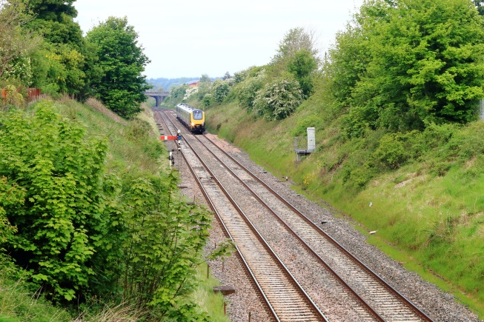
Vegetation is often found near infrastructure, including on natural and man-made slopes and alongside transport corridors. Plant roots offer potential benefits for use as a low-cost, carbon-neutral natural alternative to conventional ground reinforcement techniques. However, they are rarely incorporated explicitly within geotechnical design, principally due to perceived issues of unpredictability in location and variability in biomechanical root properties.

Though earthquakes are rare in the UK, the use of vegetation to improve the seismic performance of slopes will initially be considered. It will be shown how the study of this specific problem is particularly useful when physical modelling is to be undertaken. Centrifuge testing, combined with a novel use of 3-D printing to produce repeatable and highly representative scale model root analogues, will establish that plant roots can be just as effective in improving slope stability as conventional methods of reinforcement.

Having demonstrated the benefits of vegetation, it will further be shown how the mechanical reinforcement from roots observed in the centrifuge may be incorporated into routine Limit Analysis (LA) or Finite Element (FE) simulations. Such analyses demonstrate a fundamentally different mechanism by which roots improve stability, with knowledge of root spread and depth being at least as important as outright biomechanical root strength. Novel approaches for determining these input parameters using recently developed rapid in-situ testing techniques will be introduced.

The final part of the lecture will explore how this new insight and modelling approach may be applied to a wider range of practical problems including:
- extending the design life of slopes in seismic areas and under the effects of climate change;
- the effect of tree removal on stability of railway embankments;
- use of vegetation in debris-flow protection systems;
- understanding windthrow hazard from storms.
Through the evidence provided and the tools developed, use of vegetation can become a realistic eco-friendly technique for use in practical Geotechnical Engineering.
Please join us afterwards in the ICE Café Bar for drinks sponsored by Platipus Anchors Ltd
PTO for Dr Knappett’s biography
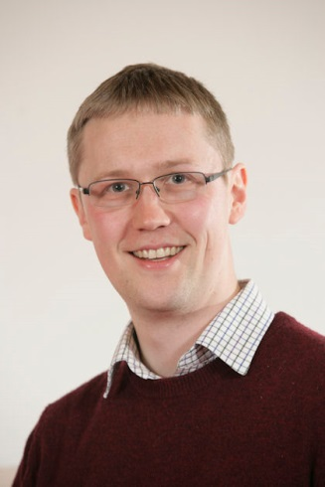
Biography – Dr Jonathan Knappett

Dr Knappett joined the University of Dundee as a Lecturer in 2006, following an MEng and PhD at the University of Cambridge. He is currently Discipline Lead for Civil Engineering, having developed and previously led the University’s successful growing MSc in Geotechnical Engineering for 8 years.

His research interests fall into three main areas:

- Earthquake Engineering;

- Biomediated Geotechnical Engineering;

- Offshore Geotechnics, primarily anchoring systems for marine renewable energy.
This research has been supported by funding from the UK Research Councils, the European Commission, and various overseas, charitable and industrial organisations to a total value of over £4.5M. Examples of active funding include Shaking Tunnel Vision (with the University of Leeds, EPSRC), Rooting for sustainable performance (with the University of Southampton, EPSRC) and Screw anchors for floating marine renewable energy incorporating anchor sharing (European Commission).

He has had multiple publications within Géotechnique in all of the aforementioned research areas over the last 11 years and was awarded the BGA Medal in 2009 and the TK Hsieh Award for Civil Engineering Dynamics from the ICE/SECED in 2010. His expertise includes centrifuge and 1-g physical modelling and Finite Element simulation.

He is the Chairman of the Editorial Panel of the International Journal of Physical Modelling in Geotechnics and is one of the instructors on the Standard and Advanced courses in Computational Modelling in Geotechnics run annually in the UK by PLAXIS BV. He is a UK National Representative on both Technical Committees TC104 (Physical Modelling) and TC203 (Earthquake Engineering) of the ISSMGE. He has previously served on the Géotechnique Advisory Panel (2011-2013) and is the principal author of Craig’s Soil Mechanics, 8th Ed. and co-author of Design of Piles in Liquefiable Soils

Please join us in the ICE Café/Bar for drinks sponsored by

Disclaimer: Any views or opinions expressed on any matters by the presenters or participants during or in connection with any presentation are solely the views of the authors of the respective comments and/or opinions and must not be taken to be the views of ICE or the British Geotechnical Association or any other organisation. ICE and the BGA make no representations, warranties or assurances concerning any information provided in these presentations and accept no responsibility for the content and/or accuracy

