BGA Touring Lecture 2017
8^{th,} 13th and 15th November 2017
Tunnelling in the Urban Environment:
engineering challenges and research

Professor Giulia Viggiani
University of Cambridge
Synopsis

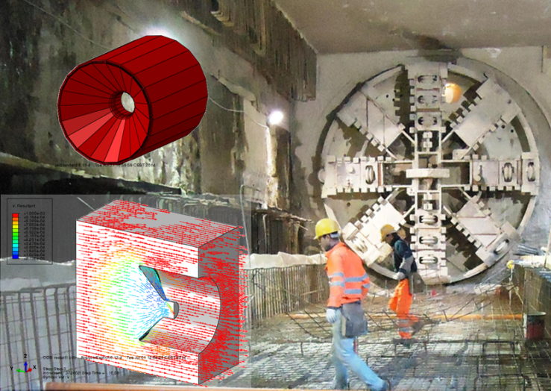
Tunnelling construction is forced to address increasingly complex scenarios, and the ability to control displacements during excavation and in the long term is often a crucial issue in the urban environment. The technical challenges stemming from the construction of large underground projects can represent an opportunity to advance our understanding of the impact of mechanised tunnelling on existing structures and to develop tools to optimise design and control construction processes.

The lecture explores this idea by illustrating the results of a collaborative research project carried out in connection to the design and construction of the third line of Roma underground. The project examined mechanised tunnelling and construction processes, tunnelling-induced damage assessment and connected mitigation and remedial measures, using a combination of field monitoring, laboratory observations, and physical and numerical modelling.

- Wednesday 8th November – Belfast

- Monday 13th November – Southampton

- Wednesday 15th November – Birmingham

Full details and biography overleaf

Disclaimer: Any views or opinions expressed on any matters by the presenters or participants during or in connection with any presentation are solely the views of the authors of the respective comments and/or opinions and must not be taken to be the views of ICE or the British Geotechnical Association or any other organisation. ICE and the BGA make no representations, warranties or assurances concerning any information provided in these presentations and accept no responsibility for the content and/or accuracy

BGA Touring Lecture 2017
Tunnelling in the Urban Environment:
engineering challenges and research

Professor Giulia Viggiani
University of Cambridge

Biography

Giulia Viggiani has just been appointed Professor of Infrastructure Geotechnics at Cambridge University. Before this, she was Full Professor of Geotechnics at Università di Roma Tor Vergata where she was Head of the Board of Studies in Civil and Environmental Engineering. She obtained a Laurea in Civil Engineering from Università di Napoli Federico II in 1989 and a PhD in Geotechnical Engineering from the City University in London, in 1994.
Her research deals mainly with underground construction, foundation engineering, and earthquake geotechnical engineering. She has been involved in many infrastructural projects in Italy and the UK, including monitoring building response to construction of the Jubilee Line Extension in London, the design and construction of Lines 1 and 6 of Napoli underground and of Line C of Roma underground, and the design of the foundations, anchor blocks and terminal structures of the Strait of Messina Bridge.

BGA Touring Lecture, hosted by the Northern Ireland Geotechnical Group at Queen’s University, Belfast
Date & time: Wednesday 8th November 2017
- 17:30 Refreshments available in the Student Hub (adjacent to Lecture Theatre 0G/012)
- 18:15 Lecture commences (Lecture Theatre 0G/012, David Kier Building, Stranmillis Road, Belfast BT9 5AG (Campus map available here).
- Contact: Keri Fitzpatrick at kfitzpatrick@cassidygeo.com; tel: 028 90798700

BGA Touring Lecture hosted by the Southern Geotechnical Group at Southampton Solent University
Date and Time: Monday 13th November 2017
- 1800: Refreshments
- 18:30 Lecture commences in Solent Conference Centre, The Spark, Southampton Solent University, East Park Terrace, Southampton, Hampshire SO14 0LY
- Contact: Ross Adams at Ross.Adams@ramboll.co.uk; tel 07855 090926

BGA Touring Lecture hosted by Midland Geotechnical Society at the Nyquist theatre at Arup offices
The Arup Campus Blythe Gate Blythe Valley Park, Solihull West Midlands B90 8AE (Junction 4 of M42, (Shirley/Solihull)
Date & Time: Wednesday 15th November 2017
- 18:15 refreshments
- 19:00 Lecture commences
- Contact: Lindsay.burt@arup.com; tel: 44 7961 129 399

Disclaimer: Any views or opinions expressed on any matters by the presenters or participants during or in connection with any presentation are solely the views of the authors of the respective comments and/or opinions and must not be taken to be the views of ICE or the British Geotechnical Association or any other organisation. ICE and the BGA make no representations, warranties or assurances concerning any information provided in these presentations and accept no responsibility for the content and/or accuracy
Disclaimer: Any views or opinions expressed on any matters by the presenters or participants during or in connection with any presentation are solely the views of the authors of the respective comments and/or opinions and must not be taken to be the views of ICE or the British Geotechnical Association or any other organisation. ICE and the BGA make no representations, warranties or assurances concerning any information provided in these presentations and accept no responsibility for the content and/or accuracy

